EXPERIMENT – 4
DETECT OUTLIERS IN A GIVEN DATASET
Aim:
To detect outliers in a given dataset

Procedure:
1.Import numpy and create an array with random integers
2.Create a function for outlier
3.Then plot it using seaborn with displot and distplot

Program:
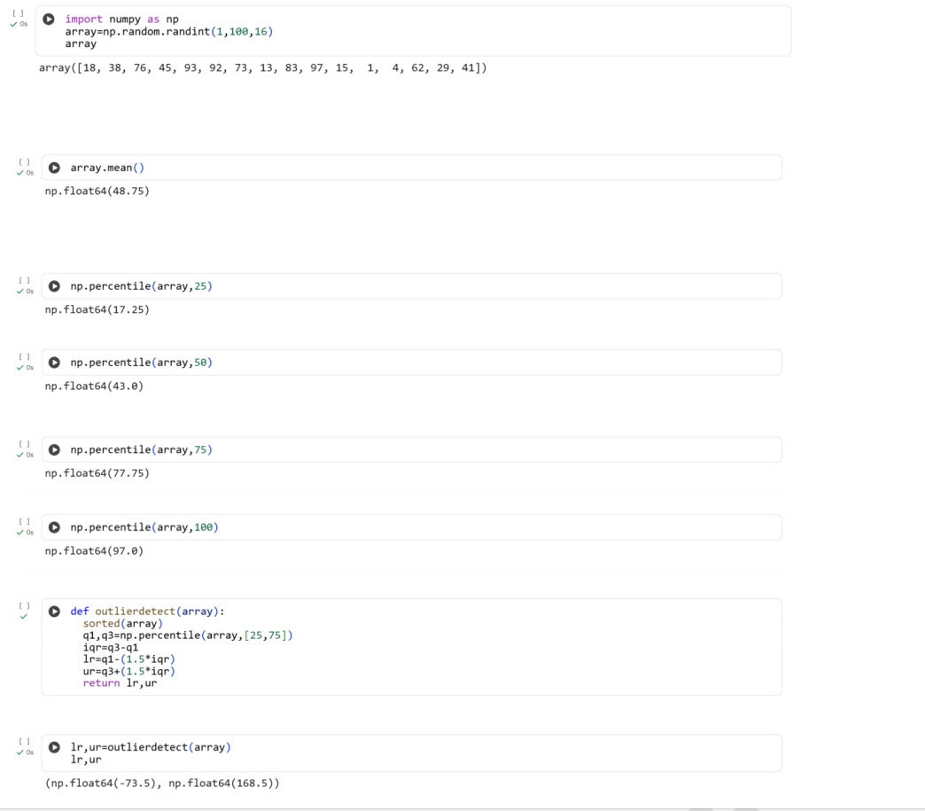

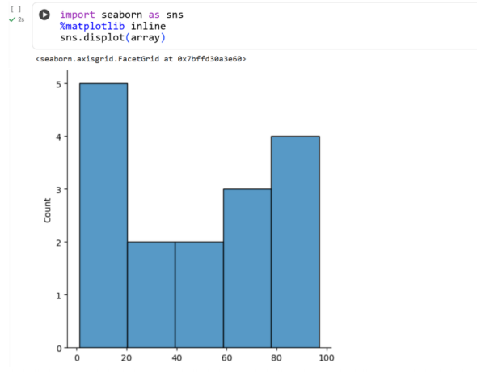
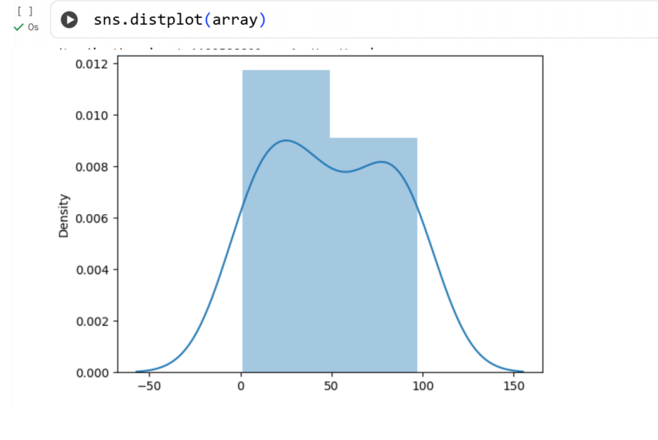
Result:
Thus the python program to detect outliers in a given dataset is executed and output
verified successfully

